**From:** Jon-Henri Quin [<mailto:Jon-Henri.Quin@sqlservices.com>]   
**Sent:** Thursday, 6 July 2017 10:02 AM  
**To:** Richard Banfield (AU) <[Richard.Banfield@dimensiondata.com](mailto:Richard.Banfield@dimensiondata.com)>; Daniel Zhou (AU) <[Daniel.Zhou@didata.com.au](mailto:Daniel.Zhou@didata.com.au)>; David Fletcher (AU) <[David.Fletcher@didata.com.au](mailto:David.Fletcher@didata.com.au)>; Minesh Chandwaskar <[minesh.chandwaskar@oakton.com.au](mailto:minesh.chandwaskar@oakton.com.au)>; Shane Coetser (AU) <[Shane.Coetser@didata.com.au](mailto:Shane.Coetser@didata.com.au)>  
**Subject:** MCP SQL Server environment - Summary

Hi All,

Below is a summary of the new MCP SQL Server environment for reference. In terms of day-to-day monitoring I have handed this over to Team west; they will now respond to any alerts that are generated on the SQL Servers. In terms of database migrations I am still working to secure a Team West resource to assist with these, so for now please continue to send any migration requests to me.

**SQL Server Instances**

The following table lists all SQL Server instances (PROD & TEST/DEV) that have been deployed in MCP, their SQL version/edition, default collation and primary function. Each environment consists of 17 SQL Server instances, installed across 10 Virtual Machines.

|  |  |  |  |  |  |  |  |  |  |
| --- | --- | --- | --- | --- | --- | --- | --- | --- | --- |
| **Virtual Machine** | **SQL Instance Name** | **Environment** | **SQL Version** | **SQL Edition** | **Default Collation** | **TCP Port** | **Cores** | **Memory (GB)** | **Primary Service Function** |
| AUMCPSVPSQLAG01 | AUMCPSVPSQLAG01 | Production | 2012 | Enterprise | Latin1_General_CI_AS | 1433 | 4 | 64 | SQL 2012 AlwaysOn - Consolidated |
| AUMCPSVPSQLAG01\SQLINST1 | Production | 2016 | Enterprise | SQL_Latin1_General_CP1_CI_AS | 1533 | SQL 2016 AlwaysOn - ChangePoint |
| AUMCPSVPSQLAG02 | AUMCPSVPSQLAG02 | Production | 2012 | Enterprise | Latin1_General_CI_AS | 1433 | 4 | 64 | SQL 2012 AlwaysOn - Consolidated |
| AUMCPSVPSQLAG02\SQLINST1 | Production | 2016 | Enterprise | SQL_Latin1_General_CP1_CI_AS | 1533 | SQL 2016 AlwaysOn - ChangePoint |
| AUMCPSVPSQLAG03 | AUMCPSVPSQLAG03 | Production | 2016 | Enterprise | Latin1_General_CI_AS | 1433 | 4 | 64 | SQL 2016 AlwaysOn - Consolidated |
| AUMCPSVPSQLAG03\SQLINST1 | Production | 2016 | Enterprise | Latin1_General_CI_AS | 1533 | SQL 2016 AlwaysOn - SharePoint 2016 |
| AUMCPSVPSQLAG03\SQLINST2 | Production | 2014 | Enterprise | Latin1_General_CI_AS | 1633 | SQL 2014 AlwaysOn - Consolidated |
| AUMCPSVPSQLAG04 | AUMCPSVPSQLAG04 | Production | 2016 | Enterprise | Latin1_General_CI_AS | 1433 | 4 | 64 | SQL 2016 AlwaysOn - Consolidated |
| AUMCPSVPSQLAG04\SQLINST1 | Production | 2016 | Enterprise | Latin1_General_CI_AS | 1533 | SQL 2016 AlwaysOn - SharePoint 2016 |
| AUMCPSVPSQLAG04\SQLINST2 | Production | 2014 | Enterprise | Latin1_General_CI_AS | 1633 | SQL 2014 AlwaysOn - Consolidated |
| AUMCPSVPSQLSA01 | AUMCPSVPSQLSA01 | Production | 2008 R2 | Standard | Latin1_General_CI_AS | 1433 | 2 | 8 | SQL 2008 R2 Legacy - Consolidated |
| AUMCPSVPSQLSA02 | AUMCPSVPSQLSA02 | Production | 2008 R2 | Standard | Latin1_General_CI_AS | 1433 | 2 | 8 | SQL 2008 R2 Legacy - Consolidated |
| AUMCPSVPSQLSA03 | AUMCPSVPSQLSA03 | Production | 2014 | Enterprise | SQL_Latin1_General_CP850_BIN2 | 1433 | 4 | 8 | SQL 2014 - SAP BI |
| AUMCPSVPSQLSA04 | AUMCPSVPSQLSA04 | Production | 2014 | Enterprise | SQL_Latin1_General_CP850_BIN2 | 1433 | 4 | 32 | SQL 2014 - SAP DB |
| AUMCPSVPSQLSA07 | AUMCPSVPSQLSA07 | Production | 2016 | Enterprise | Latin1_General_CI_AS | 1433 | 4 | 64 | SQL 2016 - Business Intelligence |
| AUMCPSVPSQLSA07\SQLINST1 | Production | 2016 | Enterprise | Latin1_General_CI_AS | 1533 | SQL 2016 - Business Intelligence |
| AUMCPSVPSQLSA06 | AUMCPSVPSQLSA06 | Production | 2016 | Enterprise | Latin1_General_CI_AS | 1433 | 4 | 64 | SQL 2016 - Business Intelligence |
| AUMCPSVTSQLAG01 | AUMCPSVTSQLAG01 | Test | 2012 | Developer | Latin1_General_CI_AS | 1433 | 2 | 64 | SQL 2012 AlwaysOn - Consolidated |
| AUMCPSVTSQLAG01\SQLINST1 | Test | 2012 | Developer | SQL_Latin1_General_CP1_CI_AS | 1533 | SQL 2016 AlwaysOn - ChangePoint |
| AUMCPSVTSQLAG02 | AUMCPSVTSQLAG02 | Test | 2012 | Developer | Latin1_General_CI_AS | 1433 | 4 | 64 | SQL 2012 AlwaysOn - Consolidated |
| AUMCPSVTSQLAG02\SQLINST1 | Test | 2012 | Developer | SQL_Latin1_General_CP1_CI_AS | 1533 | SQL 2016 AlwaysOn - ChangePoint |
| AUMCPSVTSQLAG03 | AUMCPSVTSQLAG03 | Test | 2016 | Developer | Latin1_General_CI_AS | 1433 | 4 | 64 | SQL 2016 AlwaysOn - Consolidated |
| AUMCPSVTSQLAG03\SQLINST1 | Test | 2016 | Developer | Latin1_General_CI_AS | 1533 | SQL 2016 AlwaysOn - SharePoint 2016 |
| AUMCPSVTSQLAG03\SQLINST2 | Test | 2014 | Developer | Latin1_General_CI_AS | 1633 | SQL 2014 AlwaysOn - Consolidated |
| AUMCPSVTSQLAG04 | AUMCPSVTSQLAG04 | Test | 2016 | Developer | Latin1_General_CI_AS | 1433 | 4 | 64 | SQL 2016 AlwaysOn - Consolidated |
| AUMCPSVTSQLAG04\SQLINST1 | Test | 2016 | Developer | Latin1_General_CI_AS | 1533 | SQL 2016 AlwaysOn - SharePoint 2016 |
| AUMCPSVTSQLAG04\SQLINST2 | Test | 2014 | Developer | Latin1_General_CI_AS | 1633 | SQL 2014 AlwaysOn - Consolidated |
| AUMCPSVTSQLSA01 | AUMCPSVTSQLSA01 | Test | 2008 R2 | Developer | Latin1_General_CI_AS | 1433 | 2 | 8 | SQL 2008 R2 Legacy - Consolidated |
| AUMCPSVTSQLSA02 | AUMCPSVTSQLSA02 | Test | 2008 R2 | Developer | Latin1_General_CI_AS | 1433 | 2 | 8 | SQL 2008 R2 Legacy - Consolidated |
| AUMCPSVTSQLSA03 | AUMCPSVTSQLSA03 | Test | 2014 | Developer | SQL_Latin1_General_CP850_BIN2 | 1433 | 4 | 8 | SQL 2014 - SAP BI |
| AUMCPSVTSQLSA04 | AUMCPSVTSQLSA04 | Test | 2014 | Developer | SQL_Latin1_General_CP850_BIN2 | 1433 | 4 | 32 | SQL 2014 - SAP DB |
| AUMCPSVTSQLSA07 | AUMCPSVTSQLSA07 | Test | 2016 | Developer | Latin1_General_CI_AS | 1433 | 4 | 64 | SQL 2016 - Business Intelligence |
| AUMCPSVTSQLSA07\SQLINST1 | Test | 2016 | Developer | Latin1_General_CI_AS | 1533 | SQL 2016 - Business Intelligence |
| AUMCPSVTSQLSA06 | AUMCPSVTSQLSA06 | Test | 2016 | Developer | Latin1_General_CI_AS | 1433 | 4 | 64 | SQL 2016 - Business Intelligence |

The diagram below illustrates the Production instances that are installed.

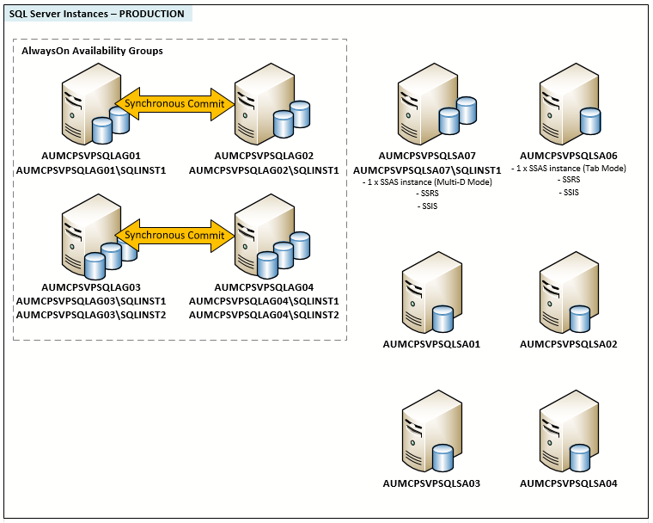

**AlwaysOn Instances**

The table below shows the SQL Server instances that are configured with AlwaysOn in both PROD & TEST/DEV.

**IMPORTANT:** Take note of the ‘***Client Connection String***’ column; when a database is configured for AlwaysOn the application/client must use this as the server name in its connection string to the database. It is a combination of the AlwaysOn Listener and port number. If this is not used, and the SQL instance name is used instead, the application will not be able to connect to the database should a failover (automatic or manual) occur.

|  |  |  |  |  |  |  |  |  |  |
| --- | --- | --- | --- | --- | --- | --- | --- | --- | --- |
| **SQL Instance Name** | **Environment** | **SQL Version** | **AwO Role** | **WSFC Name** | **AwO Group Name(s)** | **AwO Listener Name(s)** | **AwO Listener IP(s)** | **AwO Listener Port(s)** | **Client Connection String** |
| AUMCPSVPSQLAG01 | Production | 2012 | Primary | AUMCPSVPSQLAGA | PSQLAGA-AG01 | PSQLAGA-AL01 | 10.105.75.57 | 1433 | PSQLAGA-AL01,1433 |
| AUMCPSVPSQLAG02 | Production | 2012 | Secondary |  |  |  |  |  |
| AUMCPSVPSQLAG02\SQLINST1 | Production | 2016 | Primary | AUMCPSVPSQLAGA | PSQLAGA-AG02 | PSQLAGA-AL02 | 10.105.75.58 | 1533 | PSQLAGA-AL02,1533 |
| AUMCPSVPSQLAG01\SQLINST1 | Production | 2016 | Secondary |  |  |  |  |  |
| AUMCPSVPSQLAG03 | Production | 2016 | Primary | AUMCPSVPSQLAGB | PSQLAGB-AG01 | PSQLAGB-AL01 | 10.105.75.59 | 1433 | PSQLAGB-AL01,1433 |
| AUMCPSVPSQLAG04 | Production | 2016 | Secondary |  |  |  |  |  |
| AUMCPSVPSQLAG04\SQLINST1 | Production | 2016 | Primary | AUMCPSVPSQLAGB | PSQLAGB-AG02 | PSQLAGB-AL02 | 10.105.75.60 | 1533 | PSQLAGB-AL02,1533 |
| AUMCPSVPSQLAG03\SQLINST1 | Production | 2016 | Secondary |  |  |  |  |  |
| AUMCPSVPSQLAG03\SQLINST2 | Production | 2014 | Primary | AUMCPSVPSQLAGB | PSQLAGB-AG03 | PSQLAGB-AL03 | 10.105.75.61 | 1633 | PSQLAGB-AL03,1633 |
| AUMCPSVPSQLAG04\SQLINST2 | Production | 2014 | Secondary |  |  |  |  |  |
| AUMCPSVTSQLAG01 | Test | 2012 | Primary | AUMCPSVTSQLAGA | TSQLAGA-AG01 | TSQLAGA-AL01 | 10.105.71.152 | 1433 | TSQLAGA-AL01,1433 |
| AUMCPSVTSQLAG02 | Test | 2012 | Secondary |  |  |  |  |  |
| AUMCPSVTSQLAG02\SQLINST1 | Test | 2016 | Primary | AUMCPSVTSQLAGA | TSQLAGA-AG02 | TSQLAGA-AL02 | 10.105.71.153 | 1533 | TSQLAGA-AL02,1533 |
| AUMCPSVTSQLAG01\SQLINST1 | Test | 2016 | Secondary |  |  |  |  |  |
| AUMCPSVTSQLAG03 | Test | 2016 | Primary | AUMCPSVTSQLAGB | TSQLAGB-AG01 | TSQLAGB-AL01 | 10.105.71.154 | 1433 | TSQLAGB-AL01,1433 |
| AUMCPSVTSQLAG04 | Test | 2016 | Secondary |  |  |  |  |  |
| AUMCPSVTSQLAG04\SQLINST1 | Test | 2016 | Primary | AUMCPSVTSQLAGB | TSQLAGB-AG02 | TSQLAGB-AL02 | 10.105.71.155 | 1533 | TSQLAGB-AL02,1533 |
| AUMCPSVTSQLAG03\SQLINST1 | Test | 2016 | Secondary |  |  |  |  |  |
| AUMCPSVTSQLAG03\SQLINST2 | Test | 2014 | Primary | AUMCPSVTSQLAGB | TSQLAGB-AG03 | TSQLAGB-AL03 | 10.105.71.156 | 1633 | TSQLAGB-AL03,1633 |
| AUMCPSVTSQLAG04\SQLINST2 | Test | 2014 | Secondary |  |  |  |  |  |

Currently, each pair of instances have one AlwaysOn group configured i.e. we have 5 SQL instance pairs (PROD) with 5 AlwaysOn groups across them. It is possible for each pair to have multiple AlwaysOn groups; these can be added at any time without any impact to service. The diagram below outlines the AlwaysOn setup in Production.

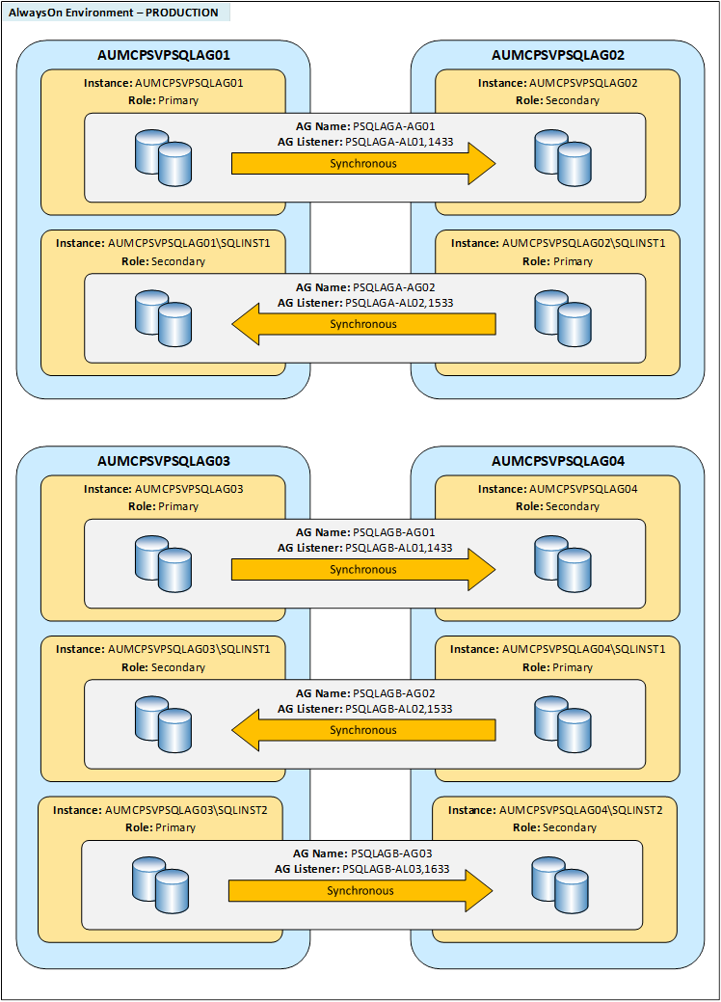

**SQL Installation Media**

It was initially requested that the SQL installation media used for each install is stored on each server. However, due to the multiple versions that have been used and the space they consume I have opted not to do this. In some cases this media was consuming over 10GB and we were duplicating this multiple times. I have therefore put all installation media used in the following location which was provided by David:

\\AUNDDMSVVC01\sqlmedia

If this location needs to change let me know the new path and I can move the files. This directory includes all of the latest SQL service packs and cumulative updates that were used for the SQL versions installed. Also includes the SSMS 2016 installation files.

Regards,

Jon-Henri